**How to Configure Authenticator App**

1. Download the app from the link on your screen or visit “[**Microsoft's Authenticator App page**](https://www.microsoft.com/en-us/account/authenticator#getapp)” for direct links to the Apple and Google Play app stores, or to get a download link sent to your phone.

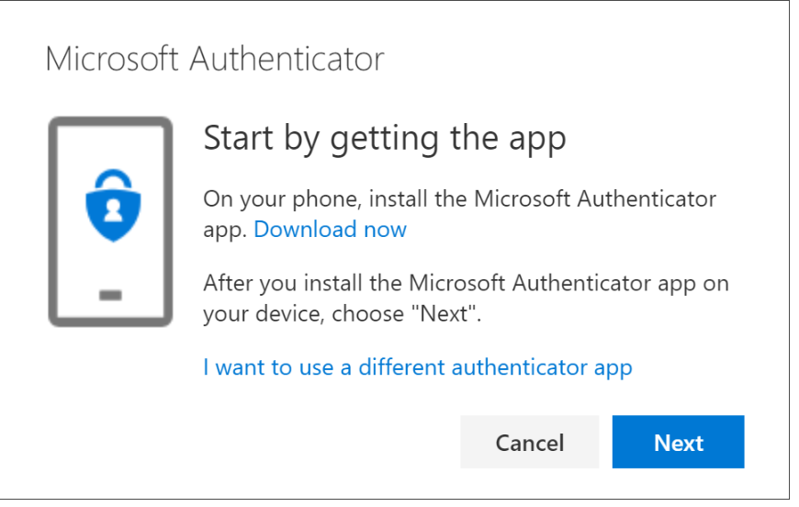

1. Remain on the **Set up your account** page while you set up the Microsoft Authenticator app on your mobile device.

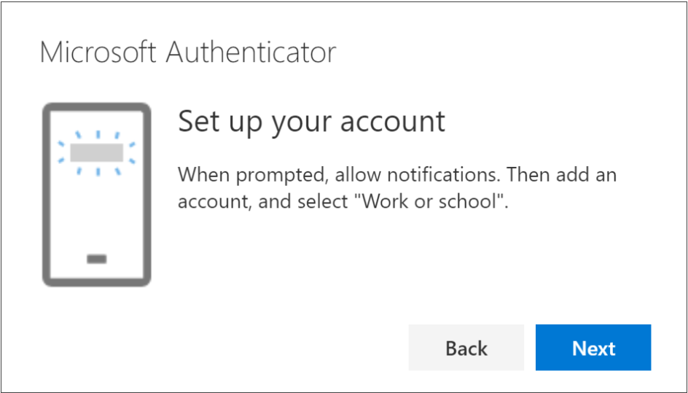

1. Once downloaded, open the app on your phone and select **Add Account or “+” sign.**

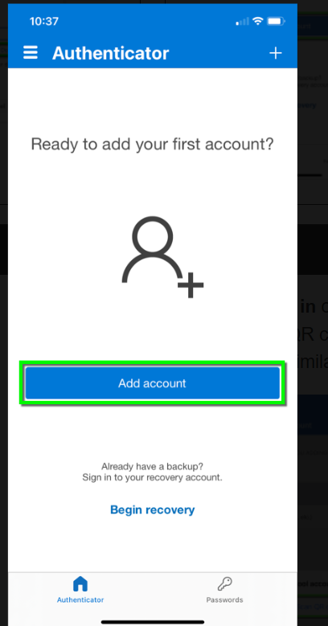

1. Select **Work or school account**.

1. Select Scan **QR code**.
2. Return to the **Set up your account** page on your computer, and then select **Next**. Scan the QR code using your app and click **Next**.

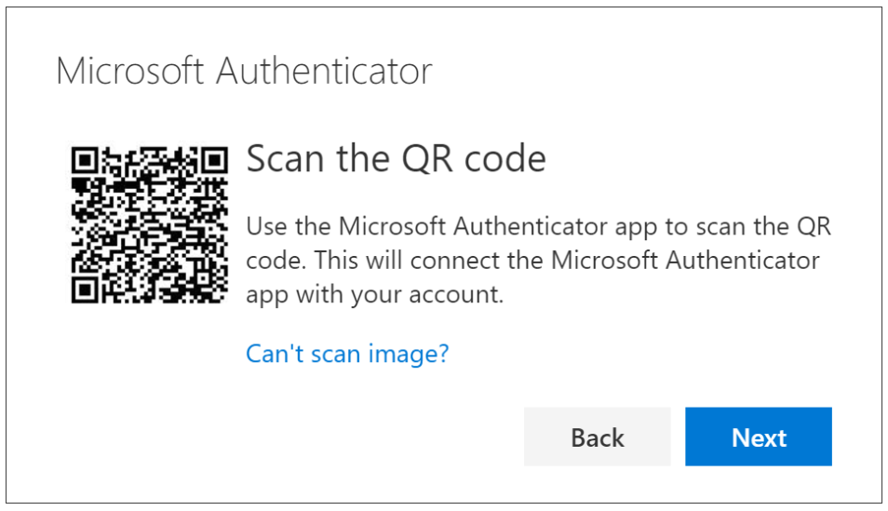

1. Select **Next**on the **Scan the QR code** page on your computer. A notification is sent to the Microsoft Authenticator app on your mobile device, to test your account.

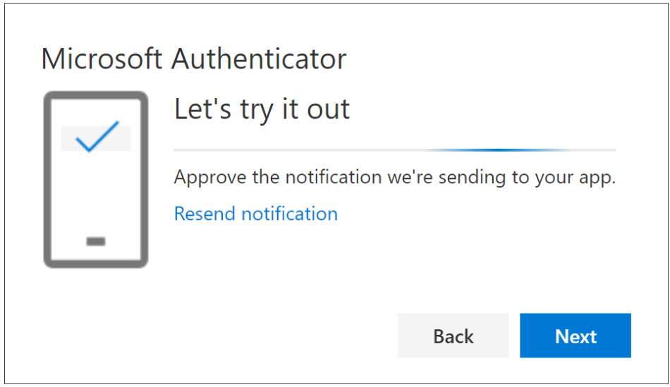

1. Approve the notification in the Microsoft Authenticator app, and then select **Next**. Your security info is updated to use the Microsoft Authenticator app.

